**Assignment No. 9**

**DEPLOY A PROJECT FROM GITHUB TO EC2**

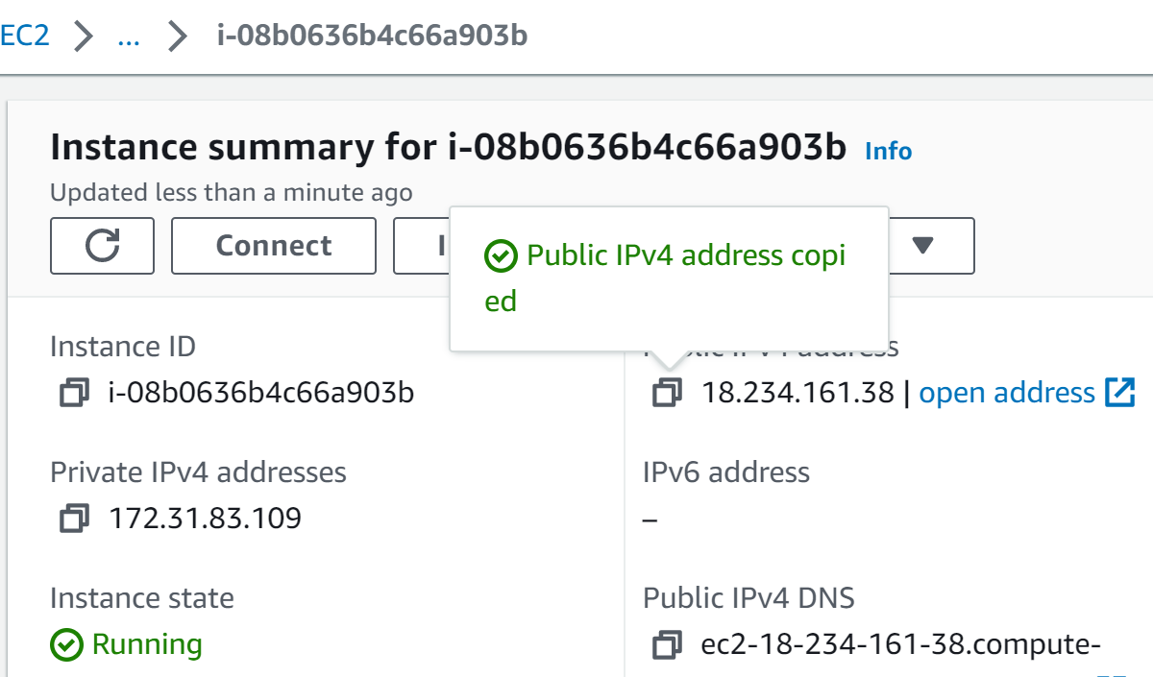

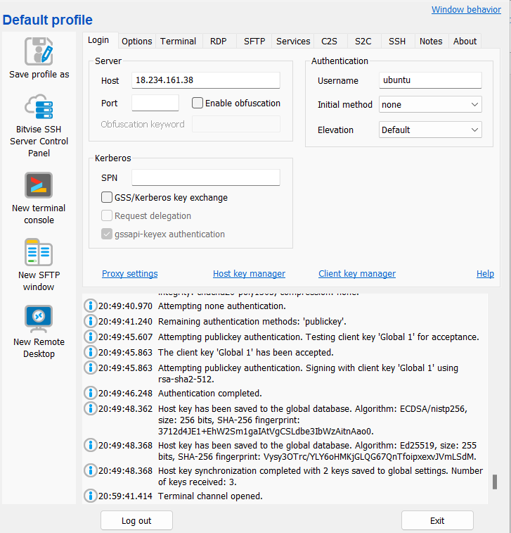

**Visit** **aws.amazon.com** **and Sign in.Create an EC2 server and copy its IPv4 address.**

**Login to Bitwise SSH client using the copied IPv4 address as host address.**

**1.….**.

**2.**

**Create a repository containing the project files in the Github and copy and save its HTTPS address for future reference**

**Create a personal access token in the Github and save it for future reference**

**s**

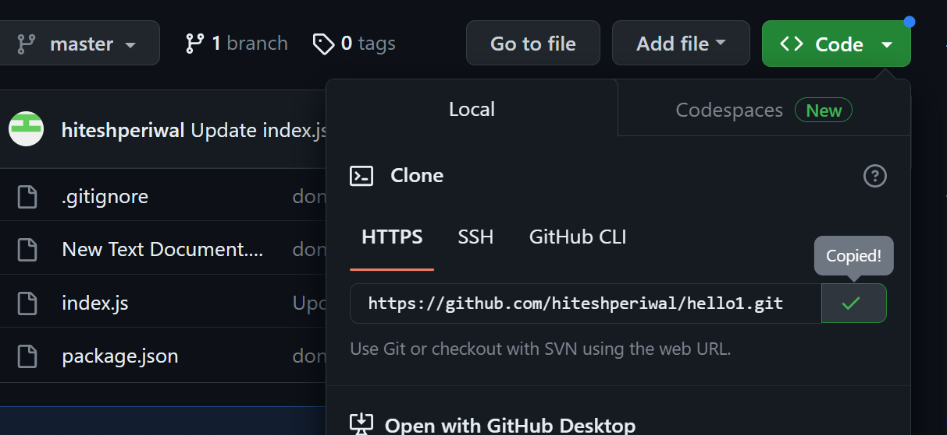

**3.**

**4.….**.

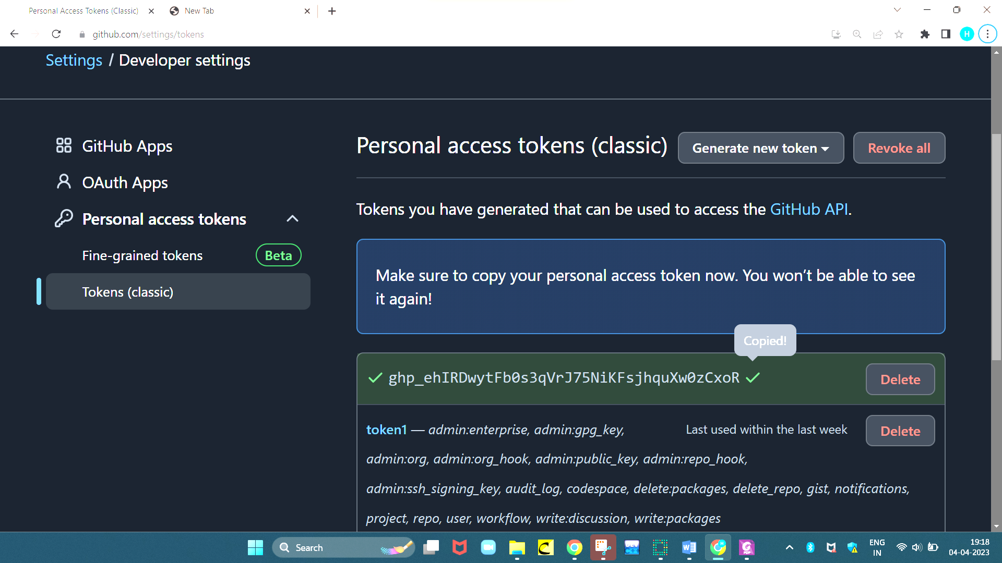











**Open a “New terminal console” in the Bitwise SSH client and type the following commands in it to install nodejs:-**

**pwd** *(to check if it is in server)*

**sudo apt-get update**

**sudo apt-get upgrade**

**sudo apt install nginx**

**nginx –v** *(to check nginx version)*

**curl –s1** [**https://deb.nodesource.com/setup_18.x**](https://deb.nodesource.com/setup_18.x) **|sudo -E bash -**

**sudo apt install nodejs**

**node –v** *(to check nodejs version)*

**node –v**

**5.….**.

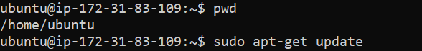

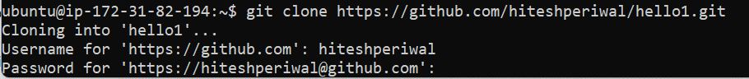

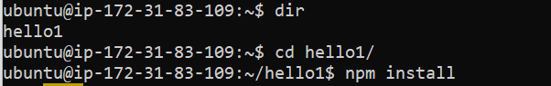



**To upload the project on EC2 server type the following commands:-**

**git clone *https address of the github hub repository where project is uploaded***

*(For username type your github username and for password enter the personal access token)*

**dir** *(to check the directory of the project)*

**cd hello1/** (to enter into repository)

**npm install** *(node package manager installation to run node commands)*

**node index.js** *(as project is uploaded start server)*

**6.**

**On pasting the public Pv4 address address of EC2 server ,the project wont load because only through specific ports it is accessible.Go to git hub and check for the ports permitted for the project by opening the index.js file.**

**Now to address this issue go to instance(in aws) -> security -> security groups -> edit inbound rules -> Add rules -> set type as custom tcp , port range as specified in index.js file, source as anywhere-IPv4 and 0.0.0.0/0 ->save rules.Now type the port number after colon in IPv4 address and the website will be accessible.**

**Hence the project is successfully deployed from github to EC2.**

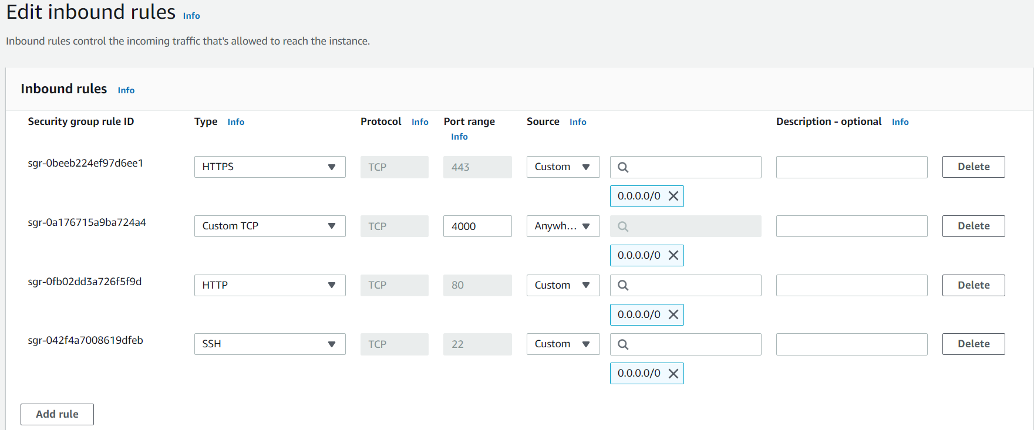

**7.**

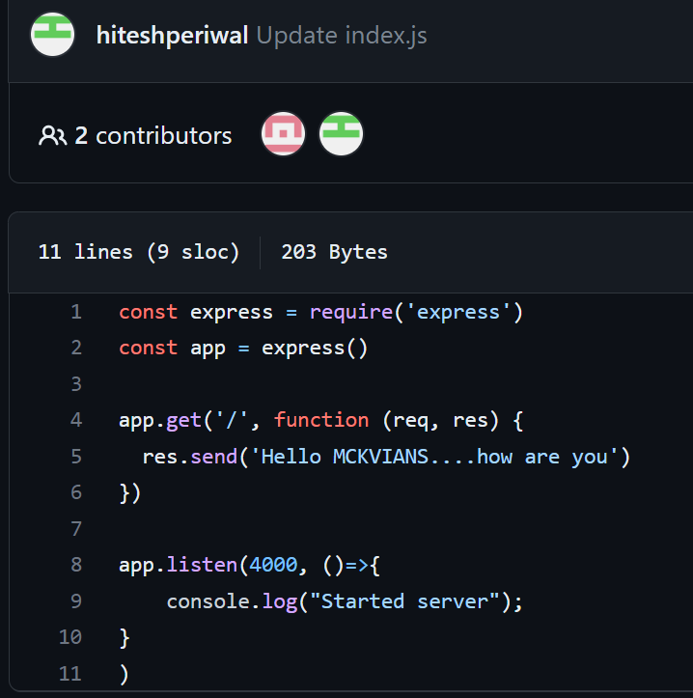

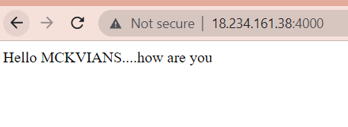

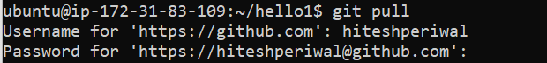



**If there is some editing done in the project it will not be reflected in the website.For that we need to terminate the server using ctrl+c and then type the follow command:-**

**git pull**

*(enter the github username and its token as password)*

**node index.js**

**Now,refresh the browser to see the changes reflected on it.**

**8.**

